# Introduction:

1. **Purpose and Overview** 
   1. Roman numeral conversion application, allow users to input either a Roman Numerals or Arabic integer, the resulting output is a conversion to the opposite number system.
   2. Roman numeral converter is intended for all age groups.
   3. The application maybe used as a quick reference for learning the symbols of the Roman Numeral System and their corresponding value and/or making quick conversions between the two systems for professional work or personal use.

# Option 1: Arabic Number to Roman Numerals:

1. Selecting the first radio button will allow the user to perform a conversion between Arabic Numbers and Roman numerals.
   1. Figure 1: outlines the steps, if one wanted to know what the corresponding Roman numeral is for the Arabic number thirty-three, follow these steps: Step 1: Select the first radio button; Step 2. Add the desired value in the text field labeled Enter a number; Step3. Click the convert button and the result will appear in the output display.
   2. The display will make a list of all conversions performed until the clear button has been pressed.

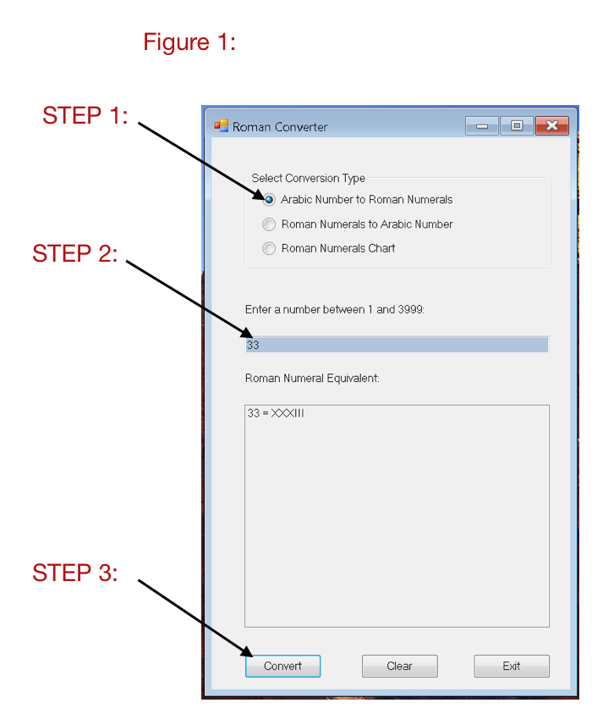

* 1. Only numbers between 1 and 3999 are valid inputs. The message Box in Figure 2 would appear if number was entered that was larger than 3999. Select OK and try entering a smaller number.

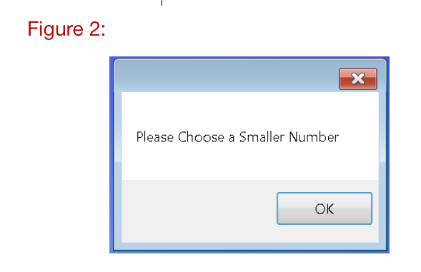

* 1. Figure 3: Message Box displays what would appear if an invalid number were entered. When imputing values only input values associated with the selected Radio Button. If the Roman Conversion to Arabic is selected only input Roman Numerals and vice versa.

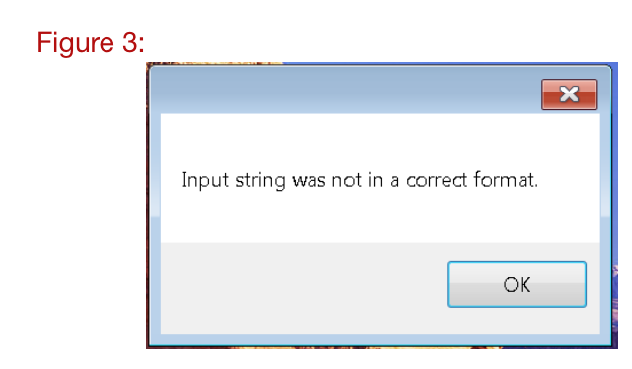

# Option 2: Roman Numerals to Arabic Number

1. Selecting the second radio button will allow the user to perform a conversion between Roman Numerals and Arabic Numbers.
   1. Figure 4: outlines the steps, if one wanted to know what the corresponding Arabic Number for the Roman numeral thirty-three, follow these steps: Step 1: Select the second radio button; Step 2. Add the desired value in the text field; Step3. Click the convert button and the result will appear in the output display.

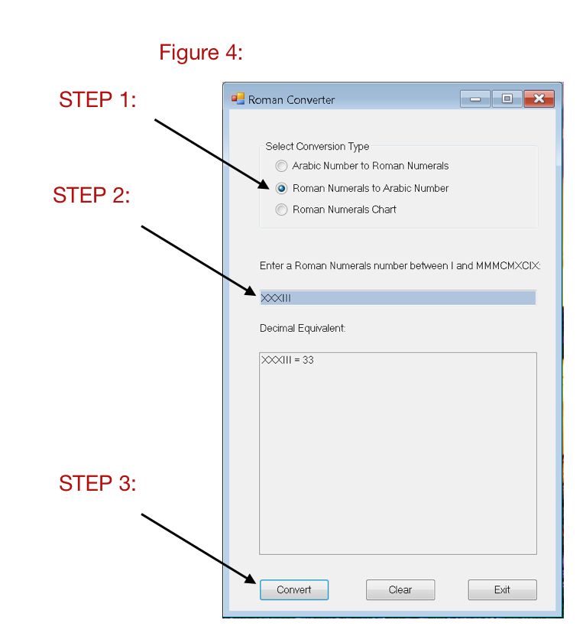

# Option 3: Roman Numeral Chart

1. Selecting the third radio button will allow the user to view a chart that will display Roman Numerals and the Arabic Equivalent from 1 – 4999 for reference.
   1. If any previous conversions have been performed, click the clear button to erase any previous conversions listed in the display and then click the Convert button.